

اختبار نهاية الفصل الدراسي الأول للعام 1447هـ
الدور الأول
المادة اللغة الإنجليزية
الصف : الرابع / الخامس السادس ابتدائي
زمن الاختبار : ساعة و نصف
التاريخ: / 5/ 1447 هـ
المملكة العربية السعودية
وزارة التعليم
الإدارة العامة للتعليم بمنطقة تبوك
مكتب تعليم
اسم المدرسة

اسم الطالبة : ..................................................

الدرجة المكتسبة

رقما

كتابة

طالبتي المثابرة سمِ الله وابدائي اختبارك
المراجعة | المصححة | الدرجة كتابة | الدرجة المستحقة رقما | الدرجة للسؤال | رقم السؤال
 |  |  |  | 6 درجات | السؤال الأول
 |  |  |  | 5 درجات | السؤال الثاني
 |  |  |  | 5 درجات | السؤال الثالث
 |  |  |  | 4 درجات | السؤال الرابع
 |  |  |  | 6 درجات | السؤال الخامس
 |  |  |  | 4 درجات | السؤال السادس
 | المدققة |  |  | 30 | المجموع

6
- General Questions:

Answer the following questions correctly:
يتبع
- What is your favorite place to visit?
A.- Diriyah is my favorite place. | B- I go shopping. | C- I visit my uncle.
- How do you go to school?
A.- BY bus. | B.- By plane. | C.- By boat.
- What school subject is more difficult at school?
A.- My favorite subject is Art. | B.- I think Math. | C.-I am shy.
- How often do you see your cousins?
a- It is mine | B- I always see them | C.-I am good.
- What time do you get up ?
A. I go to bed at 10:00 p.m. | B. I am eating lunch. | C. I get up at 7:00 am .
- What is she doing?
A.- She is good. | B.- She is shy. | C.-She is cleaning her room.

- Controlled Writing:

5

A. Copy the sentence:

This is my grandfather.

B. Complete:
Never | Third | Daddy | Washing | Son | Math

- Subjects: History , English, ________________________ .

- Family members: Father, Mother , __________________.

- Chores: Cleaning, Feeding , _________________________ .

- Informal word: Aunty, Mommy, _______________________.

- Ordinal number : First , Second ______________________.
- Adverb of frequency : Always , Sometimes, _____________.

C: Rearrange :

you / car ? /help me / Can / wash / my

يــتــبع

III- Grammar:

5
- Choose the correct answer:

- How often (…………....….) you pray? | (a) do | (b) did | (c) does
- She (………………….) a comic book . | (a) reads | (b) read | (c) reading
- Sara is (…..…………….)than Mona. | (a) tallest | (b) taller | (c) tall
- We (………...) happy at celebration . | (a) is | (b) were | (c) was
- They are his shoes. They are (…...) . | (a) theirs | (b) mine | (c) his
- Omar is (…………….....)football now. | (a) play | (b) plays | (c) playing
- (…….)do you go to the movie theatre? | (a)How often | (b) Whose | (c) where
- I am reading a (………………..…….) . | (a) pen | (b) bus | (c) comic book

- Answer between the practices :

She is doing the test now. (Make Question )

……………………………………………………………………………………..

4
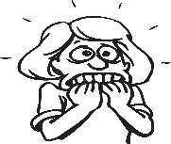  ( ) |   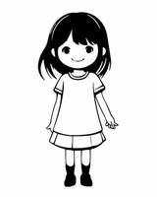  ( )
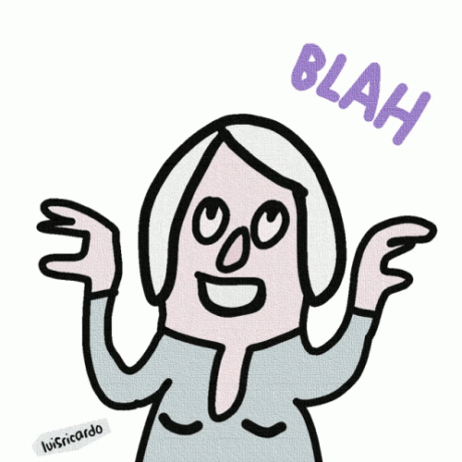  ( ) | 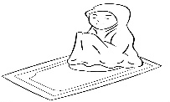  ( )
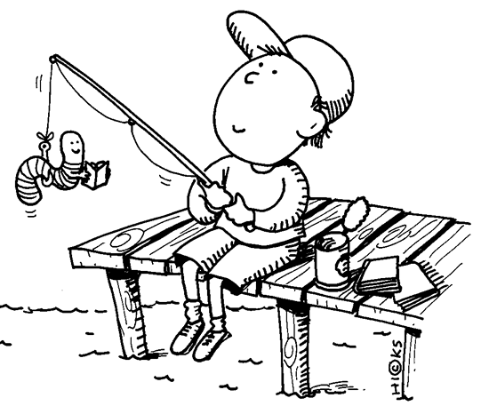  ( ) |   ( )
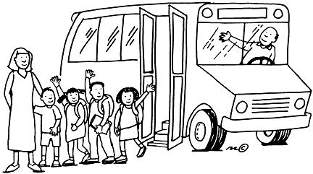  ( ) | 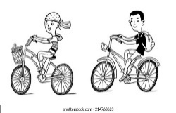  ( )
V- Reading Short Sentence:
Write the number of the sentence near the pictures:

- I get off the school bus.
- I sometimes go fishing.
- She is a chatty woman.
- She is afraid.
- She is a brilliant.
- I always pray five times every day.
- He is washing the floor.
- We usually go cycling.

يــتــبع
IV-Vocabulary

6
Write the correct number under each picture:

1-leaves | 2-Get dressed | 5-Feed | 4- Drum | 5-Dangerous | 6-wake up
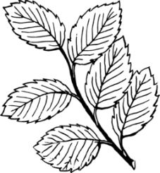
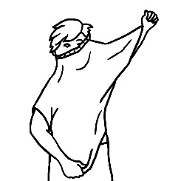
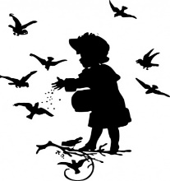
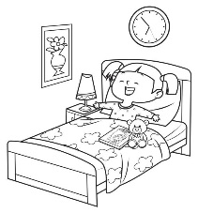

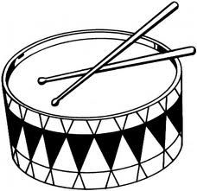

( ) ( ) ( ) ( ) ( ) ( )

VI- Orthography:

4

Fill in the missing letters:

- b | - s | - P | - f | - m | 6-i | 7-B | 8-l

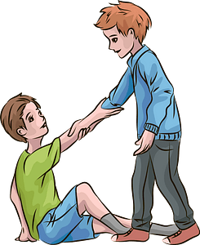 | 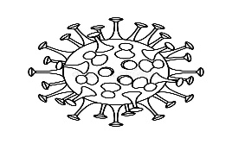 |  | 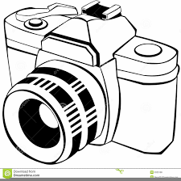
Helpful….. | …acteria | Terr…ble | Ca…..era
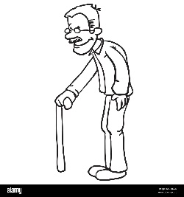 |  | 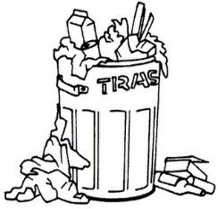 | 
Grand….ather | …..hotographer | Tra…h can | Comic …ook
انتهت الأسئلة بالتوفيق طالبتي المثابرة
Best Of Luck
T.



اختبار نهاية الفصل االأول ( الدور الأول )
للعام الدراسي 1447هـ
المادة /اللغة الانجليزية
الصف :خامس (.......)
زمن الإجابة / ساعة ونصف
التاريخ : 12/7/1443 هـ

المملكة العربية السعودية
وزارة التعليم
الإدارة العامة للتعليم بالمنطقة الشرقية
مكتب التعليم بالخبر
مدرسة ....................

30

الدرجة كتابة :

``
اسم الطالب ……………………………………………………………………….……………………………………………رقم الجلوس …………………………
Answer the general questions:
- What is the name of your dad?

My dad’s name is…………………………
- How many uncles do you have?
I have …………………………………………
- How often do you eat pizza?
I …………………..…… eat pizza.
- How do you go to school?
I go to school by ……………………..
- What chores do you like?
I like ………………………………………….
6- What chores you don’t like?
I don’t like ……………………………….

Reorder the words:

- often / How / do you / the park? / go to
………………………………………………………………………………………………………………………………....
- always / sleep early. / I
………………………………………………………………………………………………………………………………….
- car / is / This / mine.
…………………………………………………………………………………………………………………………………..
- is / playing. / He
………………………………………………………………………………………………………………………………….
- you / Can / help me?
…………………………………………………………………………………………………………………………………..

Match the questions to their answers:

1-Who is the fastest student in class? It was theirs.
2- Whose car was this? I rarely go shopping.
3-How often do you go shopping? Ahmed is the fastest student in class.
4-Whose book was this? This book was mine.
أقلب الورقة
Choose the correct words:
- How often ( do - does ) you read Quran?
- How often ( do - does ) she read a new book?
- This pen is ( your – yours ).
- He is ( sleep – sleeping ) now.
- She usually ( sleep – sleeps ) early.

Circle the correct word:
  balloons  camera | 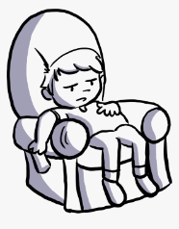  afraid  lazy | 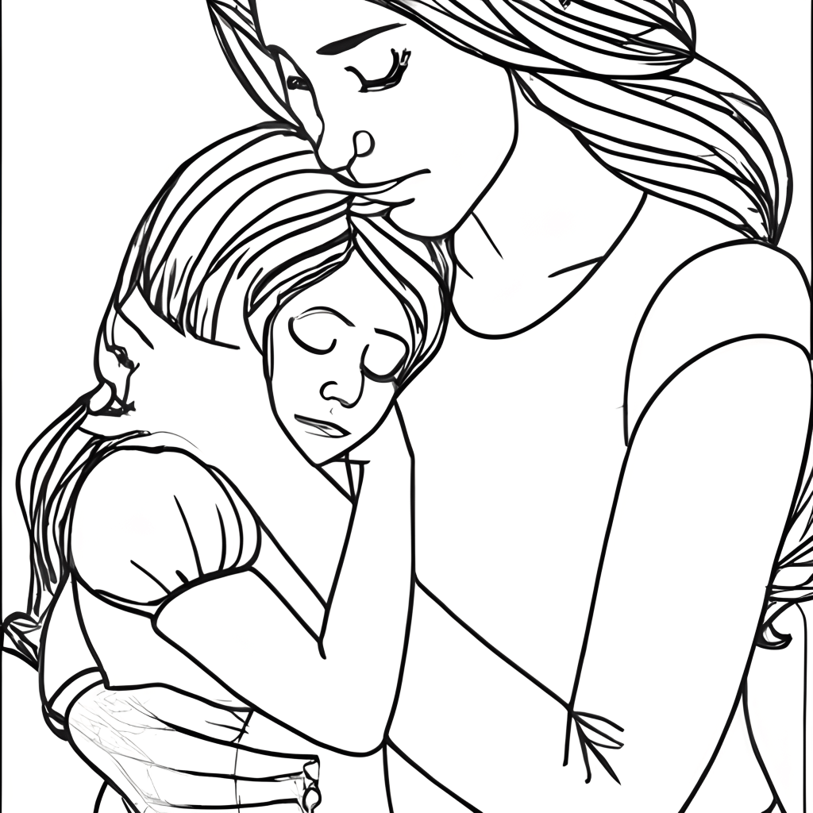  dad  mom | 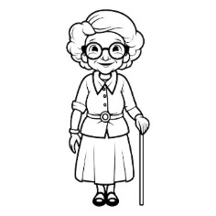  strong  grandma | 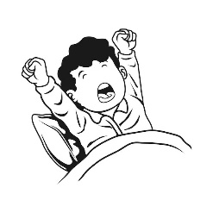  wake up  catch | 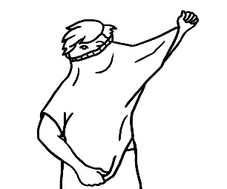  get dressed  bus

Circle the missing letter:
chatt_  y  a | ki_d  n  o | g_t up  e  l | Trash _an  d  c

انتهت الأسئلة
اختبار نهاية الفصل الدراسي الأول للعام 1447هـ
الدور الأول
المادة اللغة الإنجليزية
الصف : الرابع / الخامس السادس ابتدائي
زمن الاختبار : ساعة و نصف
التاريخ: / 5/ 1447 هـ
المملكة العربية السعودية
وزارة التعليم
الإدارة العامة للتعليم بمنطقة تبوك
مكتب تعليم
اسم المدرسة

اسم الطالب/ة : ..................................................

الدرجة المكتسبة

رقما

كتابة

- Choose the correct answer:

- What is your favorite place to visit?
A.- Diriyah is my favorite place. | B- I go shopping. | C- I visit my uncle.
- How do you go to school?
A.- BY bus. | B.- By plane. | C.- By boat.
- What school subject is more difficult at school?
A.- My favorite subject is Art. | B.- I think Math. | C.-I am shy.
- How often do you see your cousins?
a- It is mine | B- I always see them | C.-I am good.
- What time do you get up ?
A. I go to bed at 10:00 p.m. | B. I am eating lunch. | C. I get up at 7:00 am .
- What is she doing?
A.- She is good. | B.- She is shy. | C.-She is cleaning her room.
- How often …………....…. you pray?
A.- do. | B.- does. | C.-did.
- She …………………. a comic book
A.- reads. | B.- read | C.- reading
9- Sara is …..…………….than Mona
A.- tallest | B.- taller | C.- tall
10- We ……………... happy at celebration .
A.- is | B.- were | C.-am
11- They are his shoes. They are ……….......
A.- their | B.- mine | C.-am
12- …..…….....do you go to the movie theatre?
A.- How often | B.- Where | C.-What
13- Omar is ………………......football now.
A.- playing | B.- play | C.-played
14- My mom and dad are my …………......
A.- parent | B.- grandparent | C.-mother
15- I am reading a ……….…………..……. .
A.- pen | B.- comic book | C.- bus
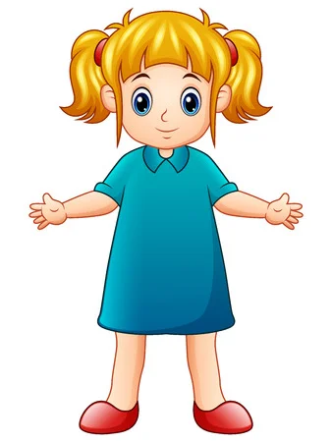16- This is my…………………….. .
A.- mother | B.- sister | C.-grandma
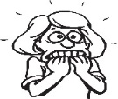
17- She is ..…………………….. .
A.- good. | B.- shy. | C.- afraid
18- She is a ..…………………….. .
A.- chatty woman | B.- cry | C.- cleaning her room.
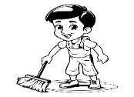
19- He is ……………………..

A.- washing the floor. | B.- feed cat | C.- cleaning the window
20- I ………….. the school bus
A.- get dressed | B.- get off | C.- get up
21- These are ……………………...
A.- comic book | B.- leaves | C.-bus
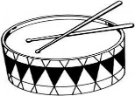
22- It is a ……………….………...
A.- drum | B.- guitar | C.-bus.

23- It is ……………..……………..
A. dangerous | B.- good | C.-nice
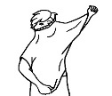
24- He is ………………………….
A.- get dressed | B.- get up | C.- cleaning
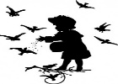
25- He is ………………the birds.
A.- sleep | B.- feed | C.- washing
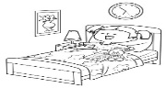
26- He always ……………….. early.
A.- get up | B.- go | C.-read.
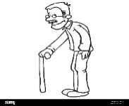
27- He is my grand ……ther.
A.- F | B.- N | C.-M

28- He is a ….hotographer
A.- S | B.- R. | C.-P
29- Heis a helpfu… boy.
A.- l | B.- o | C.-r
30- It is ca…..era
A.- o | B.- s | C.-m
انتهت الأسئلة بالتوفيق
Best Of Luck
T.

المملكة العربية السعودية  وزارة التعليم  الإدارة العامة للتعليم بمحافظة ............ |  | اختبار مادة (اللغة الانجليزية) الفصل الدراسي الاول للعام الدراسي 1447 هـ للصف الرابع والخامس والسادس
مدرسة ............................... |  | الدرجة من 30 /
الزمن / ساعة ونصف |  | المصحح / المراجع/
الاسم / الصف / رقم الجلوس :( )
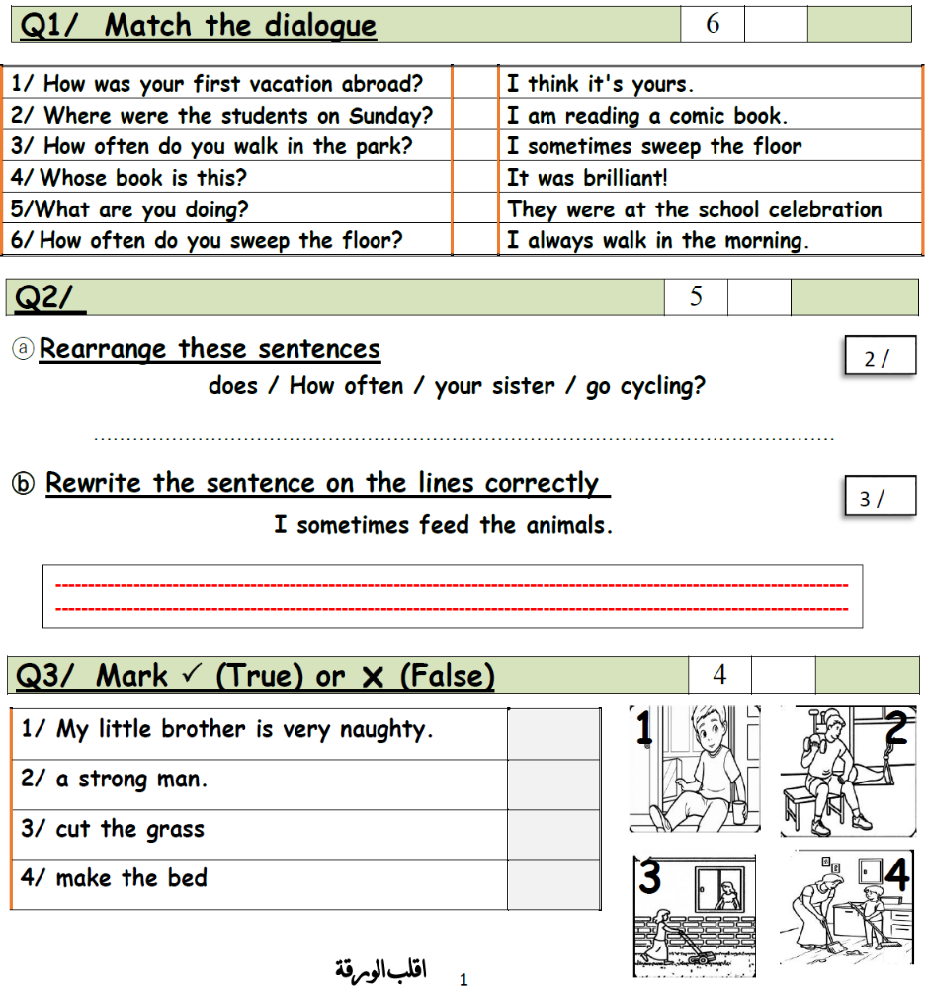

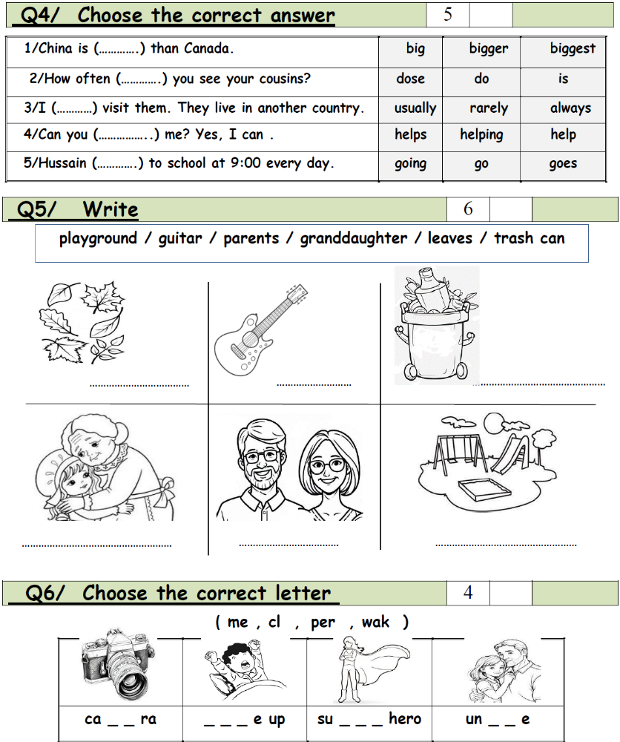

***********************************************************************************************************
انتهت الأسئلة
مـع أطيب أمنياتي لكم بالنجاح
معلم المادة : فكري عبدالله بوصبيح



30
الصف: 4 – 5 – 6 الابتدائي
الزمن: ساعة ونصف
المادة: اللغة الإنجليزية


وزارة التعليم
الإدارة العامة للتعليم بمنطقة ……..
ابتدائية ………

اختبار اللغة الإنجليزية نهائي – الدورالاول – للصف الرابع – الفصل الدراسي الاول 1447هـ
اسم الطالب: ............................................ الفصل : ..........
1- Read then put ( T ) or ( F )
My dad is a doctor . He works in a clinic . My mom is a teacher . They usually come home late and tired , so me and my sister often help with the house chores . My sister always cooks lunch and I help her . I set the table and wash the dishes . at night we usually order food from different restaurants .
1- The father is a doctor ( )
2- The mother is a nurse ( )
3- The sister always cooks lunch ( )
4- The brother always cooks dinner ( )
5- The brother doesn’t set the table . ( )

6- always 0% ( )

7- never 50% ( )

8- first 1st ( )

9- sixteenth 6th. ( )

10- Can you take out the trash? A: Yes, I can. ( )
2- Choose the correct answer:-
- I am reading a _______ | - pen | - grass | - comic book
- They water the ____ in the yard | - trash | - flower | - table
- He _______ at home. | - are | - were | - was
- Can you help me set the table? | - offer | - request | - can't
- It's my cell phone. It's _______ . | - his | - mine | - yours
- Ali ______ to school every day. | - go | - going | - goes
- ____ ____ catch the bus to school every day? | - Does she | - Is she | - Do he
- She ______reading comic book now. | - am | - is | - are

- He is ______ TV right now . | - watching | - watch | - watches
- ______ you sweep the floor for me ? | - Is | - Does | - Can
 | - wake up | - get off | - get on
 | - bus | - drum | - flower
 | - bus | - grass | - surprised
 | - son | - parents | - grandson
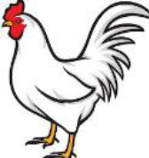 | - Leaves | - bucket | - chicken
 | - Trash can | - sweep floor | - comic book
 | - Set the table | - wash the dishes | - sweep floor
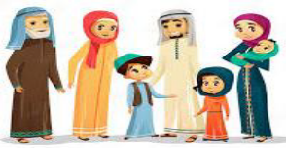  - F a __ ily | - ( z ) | - ( t ) | - ( m )
  - ca __ era | - ( m ) | - ( z ) | - ( g )
  - s __ rong | - ( z ) | - ( t ) | - ( m )


Kingdom of Saudi Arabia
Ministry of education
…….. Primary school
Sixth primary school
1.30 hours

30
الاختبار النهائي للصف السادس الفصل الدراسي الأول.
أسم الطالب: الفصل: الدرجة:
رقم الجلوس:

Reading Comprehension ✔
My dad is a doctor . He works in a clinic . My mom is a teacher . They usually come home late and tired , so me and my sister often help with the house chores . My sister always cooks lunch and I help her . I sets the table and wash the dishes . at night we usually order food from different restaurants .

/ 60001122222222222222222222222222222222222222222222222222222222222222222222222222222222222222222222222222222222222222222222222222222222222222222222222222222222220005
pppppppppp12222222222222222255555555
Mark ✔ for true ✖ for false
/ 6
1- The father is a doctor ( )
2- The mother is a nurse ( )
3- The sister always cooks lunch ( )
4- The brother always cooks dinner ( )
CHOOSE
My dad is a ( Doctor , Teacher , Chef ).
My sister always cook a ( lunch , dinner , breackfast ).
_____________________________________________________________________
/ 6
Vocabulary
CHOOSE the correct answer:
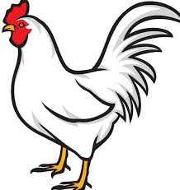 |  |  | 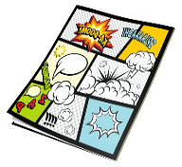 | 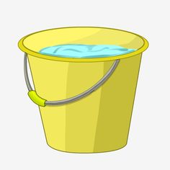
Chicken  lion | Pizza  fish | bus  rabbit | Car  comic book | Broom  bucket | Exciting  Helpful
_________________________________________________________________
/ 5
CHOOSE the correct answer :

1- How often …………………… you see your cousins? | A- do | B- have
2- How often …………………… he take the bus ? | A- has | B- does
3- Whose dress is that ? It is …………………………… | A- mine | B- I
4- Whose bike was it? It was ……………………………… | A- his | B- he
5- Whose teddy bear was it? It was ………………. | A- yours | b- you
/ 4
Read the sentences then match them with the correct pictures:
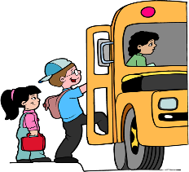 | 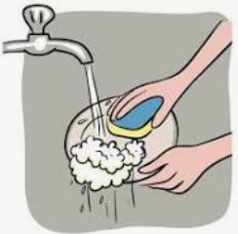 | 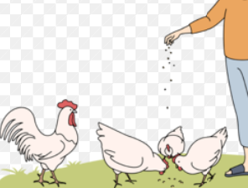 | 
a-_I get on the bus.  b-_I get off the bus. | a-She is washing the dishes.  b-_She is lazy. | a-_he is playing.  b-he is feeding animal. | a-_I often go cycling  b-_I often go fishing
________________________________________________________________
Orthography✔
/ 4

CHOOSE the correct missing letters:
  st__ong |  |   ca__era |  |   parr__t |  | 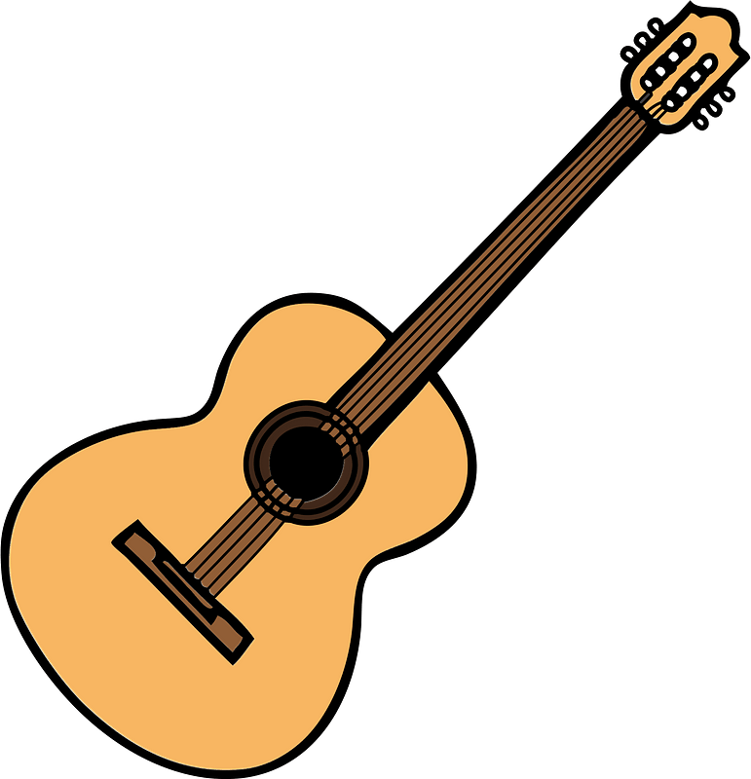  g__itar
r | c | m | n | a | o | e | U
_________________________________________________________________
/ 5
General Questions

CHOOSE the correct answer:
1- Can I help you with your homework?

a- Yes, please b- I think fish
2- What are you doing now?

a- I am watching TV b- I have 3 brothers
3- Who is chatty in your family?

a- My sister likes to talk a lot b- My brother doesn’t talk a lot
4- How often do you see your cousins?

a- It is mine b- I always see them
5- Whose pen was it?

a- Yes, Please b- It was his


المملكة العربية السعودية الصف ...
وزارة التعليم الدور الاول
مكتب تعليم ... الفصل الدراسي الاول
مدرسة : ... الزمن : ساعة و نصف

الاختبار النهائي لمادة اللغة الإنجليزية للصف ......... الابتدائي الفصل الدراسي الاول للعام الدراسي 1447 هـ
الدرجة رقماً |  | الدرجة كتابة |  | اسم المصحح | توقيعه | اسم المراجع | توقيعه
الدرجة رقماً | 30 | الدرجة كتابة | درجة فقط
الاسم الثلاثي : الصف : رقم الجلوس :

1. Answer :
6 /
1- Is an uncle a man or a woman ?
……………………………………………………………
2-What chores do you like ?
I like ………………………………………
3- What is the most difficult subject for you ?
…………………………………………………………
4- How was your vacation ?
It was …………………………………………
5- Do you make your bed in the morning ?
………………………………………………………
6- Whose bag is this ?
It is …………………………………………

2. Rearrange :
5 /
1- always / I / clean / my room
…………………………………………………………
. Copy
I always read Quran .
………………………………………………………………………………………………
4 /

3. Choose the right letter :
1. __us 2. dangerou__ 3. __irst 4. __ ifferent
s - b s - h f – h d – s

اقلب الورقة
5 /

4. Choose :
1- I …………… my grandparents. [ usually help – help usually ]
2- I always ……………to the mosque to pray. [ walk – walks ]
3- This is my car. It's ……………… [ mine – their ]
4- Yesterday, I …………… at the park. [ was – weren't ]
5- ………………… do you visit Makkah? [ How much – How often ]
4 /
5. Mark [ T ] or [F] :
1. I think it's brilliant [ ]
2. He is afraid of shark [ ]
3. He is a weak man [ ]
4. When I go on vacation, I think it's exciting [ ]





- 2. 3. 4.
6 /
6. Choose the correct word :

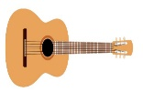


1. guitar 2. dangerous 3. brillint
drums school exciting




4. balloons 5. Playground 6. first
naughty bus second

انتهت الاسئلة

الاختبار النهائي لمادة اللغة الإنجليزية للفصل الدراسي الأول للعام 1447هـ

- GENERAL QUESTION:

6
- Choose:

- What is it? | 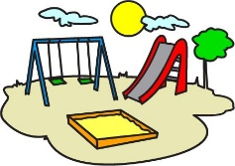  a- It's a playgroun.  b –It' guitar.
- It's …………… |   - terrible.  - afraid.
3- she's …………… | 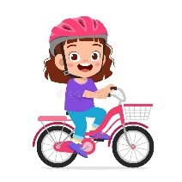  - fishing.    - cycling.
4- They're my…………… | - parents.  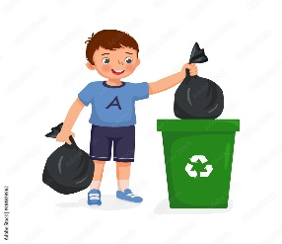  - grandparents.
5- What do you do? | 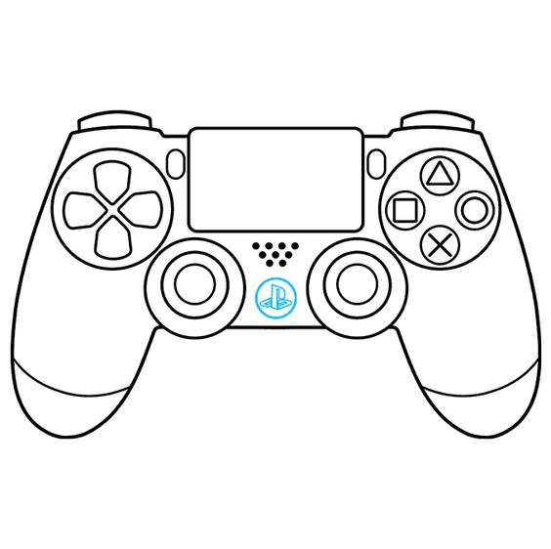    - I take out the trash.    - I set the table.
6- He's a………………man. |   - strong.  - weak.

5
- CONTROLLED WRITING:
- Do as shown between brackets:

- Can you sweep the floor? ( answer) Yes,......................................................
- My mom makes a cake. ( use usually )
………………………………………………………………………………………………………
- First Third Fourth (write the ordinal numbers)
……………… ……………… ………………

4
- READING SHORT SENTENCES:
- Read and match:

- She feeds the chickens | 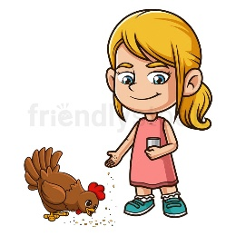
- I always read comic books
3-They catch the bus. | 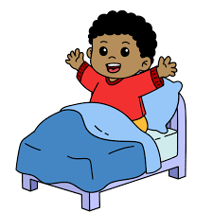
4- He always wakes up at 6:00. | 

GRAMMER:

5
- Choose :

- Amal is ( reads / reading ) the book now.
- It's her cat. It's ( hers / yours)

- How often ( does / do ) you help your family?
- I ( never / always ) walk in the park.
- He usually ( cut / cuts ) the grass.

- VOCABULARY:

6
- Match the picture with the word:

- Dangerous | - Drums | - Lazy | - Trash can | - Leaves | - grandpa

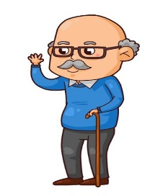  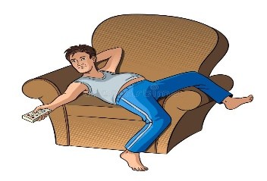 |    | 
 |  | 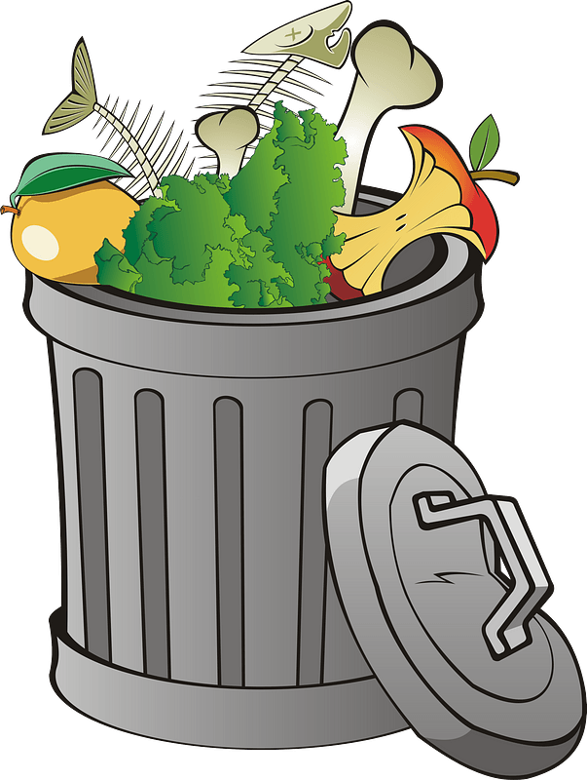

4
- ORTHOGRAPHY :


- Write the missing letter:


Ca……era ……amily ……alloon sh……
( m / k ) ( ph / f ) ( b / h ) ( e / y )

Best of luck


Kingdom of Saudi Arabia 5th & 6th Elementary Grade
Ministry of Education Time: An hour and a half
3rd Elementary School Number of papers: 3 . Final Exam – First Term – 1447 AH
- General Questions:
/6
- Choose the correct answer:
1- What are you afraid of?
a- my little brother b- spiders
2- What school subject is more difficult?
a- Math b- I go to school by bus
3- Who is chatty in your family?
a- My sister likes to talk a lot b- My brother doesn’t talk a lot
4- How often do you see your cousins?
a- It is mine b- I always see them
5- Can I help you with your homework?
a- Yes, please b- I think fish
6- What are you doing now?
a- I am watching TV b- I have 3 brothers
- Controlled Writing:
/5
- Rearrange the words to form a sentence:
photos – I – take – rarely
- Fill in the missing words:
(takes out – feed – sweep – wash – make – clears)
My brother and I help our grandparents on Saturdays. I usually (1)……………... the floor and (2) ……………... the beds. Then, I (3)……………... the animals. My brother (4)……………... the trash. My brother always (5)……………... the table after we eat and then I (6)……………... the dishes for my grandma.
- Reading short sentence:
/4
- Read the sentences then match them with the correct pictures:
 | 
a-_I get on the bus.  b-_I get off the bus. | a-_She is shy.  b-_She is lazy. | a-_It is good.  b-_It is terrible. | a-_I often go cycling  b-_I often go fishing

- Grammar:
/5
- Choose the correct answer:
- They ……… swimming in the pool.
- was b- were c- is
- It is her dress. It is …………
- yours b- mine c- hers
- Huda is ………… than Rana.
- tall b- taller c- tallest
- Hind ………… a story now.
- read b- reads c- is reading
- ………… Ali catch the bus?
- Does b- Is c- Are
- Vocabulary:
/6
- Choose the correct answer:
 |  |  |  |  |  |  | 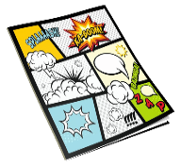
different  dangerous |  | pizza  fish |  | brilliant  surprised |  |  | car  comic book |  | broom  bucket |  | Exciting  Helpful
- Orthography:
/4
- Choose the correct missing letters:
st__ong |  |  | ca__era |  |  | parr__t |  |  |  | g__itar
r | c |  | m |  | n | a |  | o |  | e |  | U
  d__st |  |  | 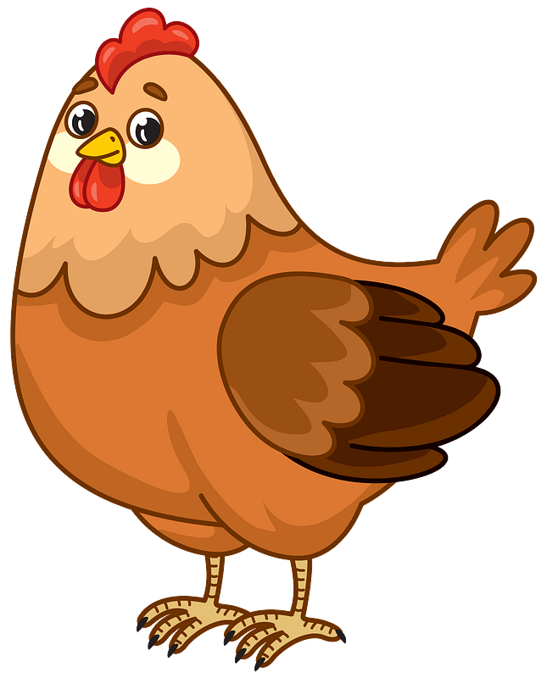  chicke__ |  |  | 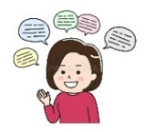  chatt__ |  |  |  | 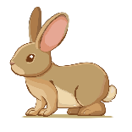  r__bbit
a | u |  | u |  | n | i |  | y |  | a |  | B

BEST OF LUCK
Ms. Tahani Al-Ghamdi


المملكة العربية السعودية الصف :
وزارة التعليم الفصل الدراسي الأول
مدرسة : الزمن : ساعة و نصف

الاختبار النهائي لمادة اللغة الإنجليزية للصف الرابع ابتدائي للعام الدراسي 1447 هـ
اسم الطالب : الصف : رقم الجلوس

30

General Questions

Match "A" with "B":

A |  | B
1. eighteenth |  |  | - I usually walk in the morning
2. How do you go to school? |  |  | - 18th
3. He doesn’t talk a lot |  |  | - she is very naughty.
4. How often do you walk in the park? |  |  | - by bus
 |  |  | - He is shy

6

Circle ( T ) for true or ( F ) for false

- Diriyah is near to Riadh  
- Germs and bacteria love dirty places.  

Controlled Writing

- The ordinal numbers for six is ____________ ( answer )
- daddy _________ (change to formal )
- My mom's sister is my __________ ( complete)
- Can he swim ? No, he_________ . ( complete)
- are – What – doing – you – ? ______________________ . ( rearrange )

5

Reading Short Sentences

Read the sentences and match:
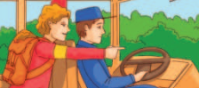
4

- She is sweeping the floor.
- The shark is near me, I am afraid.
- She is looking at the chickens.
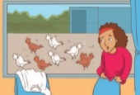

- He rides on the bus.

5
Choose the correct answer :

c) my | b) mine | - me | - This book is_________
c) feeding | b) feeds | a) feed | - I usually ________ my pet rabbit .
c) were | b) is | a) was | - Yesterday___ a nice day.
c) taller | b) tallest | a) tall | - Ali is _______ than Sami .
c) Yes, I do. | b) Yes, I can. | a) Yes, I am. | - Can you make a bed? | a) never

Grammar

Vocabulary
6

Look at the pictures and match the numbers to the correct pictures :
- parents
- get up
- trash can
- leaves
- chatty
- ballons

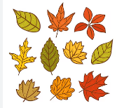






Orthography

4
Fill in the missing letters :
sh
ea
ma
ir



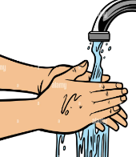


w_ _k
grand _ _
wa _ _
th _ _ d

