
المملكة العربية السعودية الصف: الأول متوسط
وزارة التعليم الفصل الدراسي: الأول
الإدارة العامة للتعليم بمحافظة الليث العام الدراسي 1447 هـ
مدرسة متوسطة وثانوية حفار الزمن: ساعة ونصف
الاختبار النهائي لمادة اللغة الإنجليزية – الصف الأول متوسط – الفصل الدراسي الأول (الدور الأول) لعام 1447 هـ
عزيزتي الطالبة:
- استعيني بالله ثم اجيبي عن الأسئلة
- فضلا تأكدي من كتابة اسمك الرباعي ورقم الجلوس
- الإجابة باللون الأزرق فقط

اسم الطالبة رباعيا
رقم الجلوس: |  | الصف: الأول متوسط | المادة: اللغة الإنجليزية
اليوم: | التاريخ: / / 1447 هـ

المدققة وتوقيعها | المراجعة وتوقيعها | المصححة وتوقيعها | الدرجة كتابة | الدرجة رقما | السؤال
Guided
Composition
 |  |  |  |  | Reading Comprehension
 |  |  |  |  | Grammar
 |  |  |  |  | Vocabulary
 |  |  |  |  | Orthography
 |  |  |  | 30 | المجموع


Kingdom of Saudi Arabia 1st Intermediate Grade
Ministry of Education Time: An hour and a half
Hifar Intermediate and Secondary School Number of papers: 3
Final Exam – First Term - 1447 AH
- Guided Composition:

6
“I am who I am!”. Use the following word bank to write a paragraph about
your yourself.
Word bank: (years old – from – Saudi – student – like – live – favourite)
________________________
__________________________________________________________________________________________________________________________________________________________________________________________________________________________________________________________________________________________________________________________________________________________________________________________________________________________________________________________________________________________________________________________________________________________________________________________

6
- Reading Comprehension:
Read the passage and answer the questions below:
My name is Jana. I have a friend. My friend lives in London. Her name is Jessica Roberts. She is seventeen years old. She likes to read. She is a good reader. She is smart so she is good at math. It is her best subject. I like to eat lunch with her. We eat lunch on Monday, Tuesday, and Wednesday. I like her a lot.
- Answer the following question:

- Where does Jessica live?
………………………………………………

- Choose the correct answer:
- This text is about:
- Jana’s pet | - Jana’s school | - Jana’s friend | - Jana’s family
- Jessica Roberts is ………………… years old.
- 7 | - 17 | - 70 | - 71
- Jessica’s hobby is …………………
- reading | - drawing | - swimming | - cooking
- Smart means:
- happy | - sad | - sleepy | - intelligent
- We in line 3 refers to:
- Jana&Jessica | - Jana | - Jessica | - math teacher

- Check ( T ) or ( F ):

- Jessica likes math. ( )
- Jana and Jessica have lunch together on weekends. ( )
- Jana’s friend last name is Roberts. ( )
- Jana’s friend is a girl. ( )
- Jana and Jessica have lunch together two times a week. ( )

7
- Grammar:
- Choose the correct answer:

- Mr. Omar ……… a teacher.
- Am | - is | - are | - can
- I am Lora. This is ……… mother.
- Your | - his | - our | - my
- …………. is your name?
- Why | - How | - What | - Where
- I have an appointment with the dentist ……… Monday.
- in | - on | - at | - from
- …………. are my keys.
- This | - Them | - These | - That
- ………… sun rises in the east and sets in the west.
- A | - An | - The | - Ø
- Mr. Ali is here ………. business.
- in | - on | - from | - at
- A: Are they Chinese?
B: No, …………….
- not they are | - are they | - they are not | - they no are
- Hanan ……… a big house.
- has | - have | - am | - are
- This is ………… book.
- Amal | - Amal’s | - Amals | - Amals’

- Do as shown between brackets:

- This is my sister. His name is Nada. (Correct the mistake)
…………………………………….
- (Use a or an)
- …….. egg
- …….. car
- Can you open the window? (Agree)
……………………………………

- Vocabulary:

7

- Write the words under the pictures:
scissors – turtle – married – radio – tourist


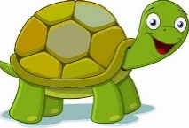


___________ ___________ ___________ ___________
- Classify the words:

parrot – pencil – skeleton – niece

Family | School Supplies | Animals | Museum Items
- Choose the correct answer to fill in the blank in each question:

- ‘enormous’ means:
- very small | - very big | - new | - single
- A …………. is the son or daughter of an uncle or aunt.
- nephew | - brother | - wife | - cousin
- August is the ………… month of the year.
- first | - eighth | - second | - fourth
- We ……….. with crayons.
- color | - cut | - cook | - read
- Circle the odd word:

- morning – afternoon – husband – night
- Bye – Hello – See you later – Take care

- Orthography:

4

- Choose the correctly spelled word:
- sester – sister – sistar – sestar
- headphones – headfones – hedfones – hedphones
- langewge – langoege – language – langwge
- Novambar – November – Nofambar – Noovamber

- Complete the missing letters:

- They went to Euprope on va__ation.
- The child lost his t__y.
- I want to be a science teach__r.
- I usually eat at home with my fami__y.

END OF QUESTIONS
BEST OF LUCK
Ms. Tahani AlGhamdi
 |  | اختبار الفصل الدراسي الأول  عام 1447  اللغة الإنجليزية  للصف اول متوسط  الزمن: 45 دقيقه
  المملكة العربية السعودية
  وزارة التعليم
  تبوك
  المتوسطة الحادية والعشرون

اسم الطالبة: الفصل:

20
1- Write at least 4 sentences about Sara. Use guide words.
20
[ my name – eleven years old – from Jeddah – like cats – because – cute- do not like dogs - scary –]

……………………………………………………………………………………

…………………………………………………………………………………….

……………………………………………………………………………………..

…………………………………………………………………………………….

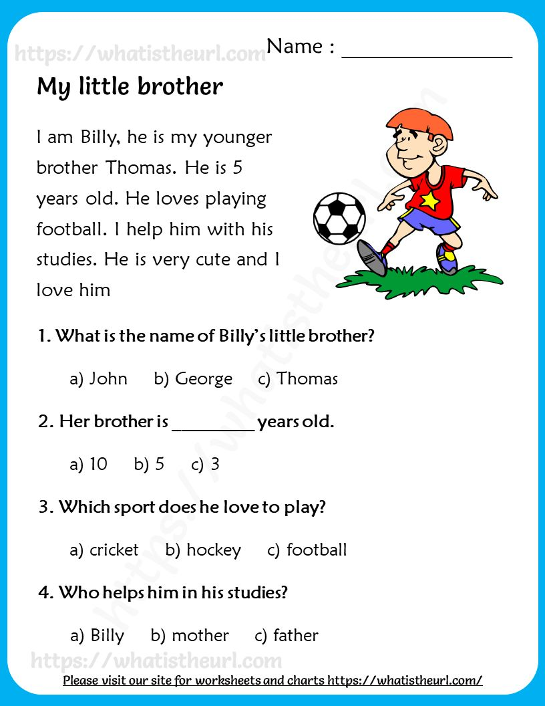
2-Read the following passage and choose the correct answers:
3-GRAMMAR/A. Choose the correct answer.
1-This is my friend .She (is – are -am) a teacher.
2-(-I’m a student. (Her – My – His )name is Alan.
3-Their final test is (on – in – at ) April 14th.
4- (What – How – Where ) old are you?
B. Do as shown between brackets. [ Correct]
1-What is you name? ………………
2-This is the teacher. My name is Mr. Ahmed……….. …………………………………………………………………………………………
4- VOCABULARY: A-Choose the correct verb
…1- We ( read – cut ) books.
2. We ( cut – color) with scissors…
Eewinter - toy- scissors - cat - eraser



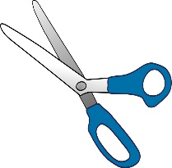
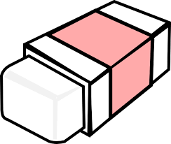

……………….. ……………………. ………………….. ………………….

5- Fill in the missing letters:

1-cra…on [ t – o -y] 2- penc…l [ i - a -y]
3- me…ting [ L – e -h] 4- c…te [ u – o -d]

T.AFAF Salem



20
20

 | الدرجة | المصحح | التوقيع | المراجع | التوقيع | الدرجة النهائية
السؤال الأول |  |  |  |  |  | رقماً | كتابة
السؤال الثاني
السؤال الثالث
السؤال الرابع |  |  |  |  |  | المدقق | التوقيع
السؤال الخامس |  |  |  |  |  | (لجنة التدقيق)
امتحان listening
المجموع

I - { Composition }
- Write a short paragraph of six sentences on: (yourself):
Eewinter - toy- scissors - cat - eraser
Name: Ali
Age:13
Nationality: Saudi
Favorite hobby: Reading
Favorite sport: football
Favorite subject: English

……………………………………………………………………….
…………………………………………………………………………………………………………………………………………………………………………………………………………………….……………………………………………………………………………………………………………………………………………………………………........................................................................................................................................................................................................................................................................………………………………………………………………………………………………......................................................................................................................................................................................................................................................................................................................................................................................................................................................................................................................................................................................................................................................

First Term Kingdom of Saudi Arabia
First Intermediate grade Ministry of Education
English Language Time : 90 minutes

II- { Reading Comprehension }
اسم الطالب: ............................................................................. رقم الجلوس:.......................................

6
- Read the following passage, then answer the questions below:
Sami is a great doctor. He lives in Riyadh . He works in King Faisal Hospital. He has a beautiful wife and 5 wonderful children. His house is big. It is white. There is a garden in the house. His children like football. They play football in the garden. The house is opposite a bog mosque . He and many people pray in the mosque. He goes to the hospital by car.
A) Answer The following questions:

1- What does Sami live?

…………………………………………………………………………………………………
2- What color is his house?

…………………………………………………………………………………………………
B)- Choose the correct answer:

1-Sami has ………..… children (five – six - seven)

2- Sami’s house is ………a big mosque (next to –near - opposite)
C- Put (T) or (F):

1- Sami goes to the hospital by bike . ( )

2.Doctors work in hospital. ( )

III {Grammar}
Page 2
(A)Choose the correct answer between brackets :
- ……………Sultan Ahmed a teacher?
- Is b- Are c- Were d- Can
- I am student. …………………….name's Samir.
- My b- Your c- His d- Her
- This is ……………. washing machine.
- a b- an c- that d- those
- Her final test is ………………. May 15th.
- on b- in c- at d- of
(B) Do as shown between brackets: -

6
1 –He is a student. (Negative)
……………………………………………………….
2 – They are at school. (Make a question)
……………………………………………………………..
3- Sunday, Monday,……………. , Wednesday (Complete)
Kingdom of Saudi Arabia 
Ministry of Education
Third Year intermediate Exam 1444 AH Time : 2 hours
مدرسة الضاحية الأهلية المتوسطة بنين (الفصل الدراسي الأول ثالث متوسط ) Eastern Region (English Language) اسـم الطالب / ………………………………………… رقم الجلوس/............. Dahia private schools
اختبار الفصـــل الدراســي الأول للعــام الـدراســي 1444هـــ (ثالث متوسـط )

IV – { Vocabulary }

7
(A) Fill in each space with a word from the following list:-

[sunday – Nice–first]
- …………..….to meet you, Asma.

- Today is Saturday. Tomorrow is………………..
- January is the ……………..month of the year.

(B) Circle the correct answer:-
Page 3
1-There are ………………….days in the weeks
a-three b- four c- seven d- five
2-I am from Saudi Arabia. I'm ……………
a- British b- Mexican c- Saudi d- Egyptian
3-My final test is ………September.
a- in b- on c- at d- to
4-…………….day is today? It's Sunday
a-What b- Where c- When d- Why

V- {Orthography}

7
Match Column (A) with its meaning in Column (B):-

( A ) | ( B )
1- crayon | ( …….. ) write
2- pencil | ( ……. ) erase
3- eraser | ( ……. ) color
4- scissors | ( ……. ) clean
 | ( ……. ) cut

انتهت الأسئلة *
معد الأسئلة أ /
التوقيع :

*Good luck

المملكة العربية السعودية
وزارة التعليم
إدارة التعليم بمنطقة الحدود الشمالية
مكتب التعليم بطريف
متوسطة و ثانوية المعهد العلمي

أسئلة اختبار العام الدراسي 1447 هـ الفصل الدراسي الأول

اسم الطالب: |  |  | رقم اللجنة: | رقم الجلوس: |  | تم الجمع
  المــــــــــــــادة | اللغة الأنجليزية
  السنـــــــــــة | الأول متوسط
  الزمـــــــــــــن | 1:30
  الفصـل الدراسي | الأول لعام 1447
السؤال | الدرجة رقما | الدرجة كتابة | اسم المصحح | توقيعه | اسم المدقق | توقيعه
الأول |  |  | عبدالرحمن |  | عبدالله | تمت المراجعة  تم التدقيق
الثاني
الثالث
الرابع
الخامس
المجموع |  | درجة فقط

6
Q1-Composition:
Write a paragraph about ( Yourself ) use the answers of these questions:
1-What is your name?
2-How old are you?
3-Where are you from?
4-What is your nationality?
5-What do you do?
My Self

________________________________________________________________________________________________________________________________________________

6
Q2-Reading:
Read the passage and answer the questions:
My Father
I love my father. He is very kind. He is called Robert. He is 45 years old. He is an active person. He gets up Early to get ready for his work. He is an architect. He is always design high skyscrapers.

Q3.Answer the following questions:
A – Choose the correct answer:
1-His father's name is……. | a-Ahmad | b-Robert | c-Billy | d-Jaky
2-His father age ……. | a-55 | b- 45 | c-54 | d-44
3-He get up ………. | a-early | b-late | c-slowly | d-quickly
4-His father is very ……. | a-kind | b-happy | c-teacher | d-sad
( 1 )
B- Write ( T ) or ( F ) at end of each statement:
1-He is an active person ( )
2-He love his father ( )
7
Q3-Grammar:
A-Choose the correct words:

1- They …… learning English | a-he | b-are | c-yes | d-no
2-He …. a teacher | a-are | b-she | c-is | d-do
3-I …….. from Saudi Arabia. | a-am | b-is | c-are | d-he

C- Write the correct articles ( a – an – the ) :

1-………. Orange. 2-……..Pen
3-…….. Sea 4-…….. ice cream.

( 2 )

7
Q4-Vocabulary:
A-Match the correct word for each picture:

Grandmother – Pen – Dolphin – camera – cat – scissors – car
 | 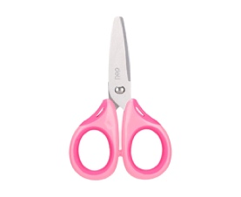 |  | 

………………… ………………. ……………… …………………

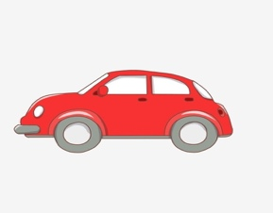 | 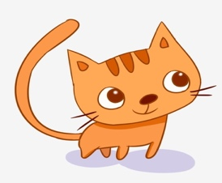 | 

……………….. …………….. ……………….

( 3 )
4
Q5-Orthography (Spelling ):
A-Choose the missing letters:
o - m - a - i

1. Fam….ly 2. bo…..k 3. Ca…era 4. c….t

C-Copy this sentences :

1-The girl have a brother ………………………………….
2-He is a doctor ………………………………….

مادة اللغة الإنجليزية
أ. عبدالرحمن البناقي

